**Access and Identity Provisioning**

**TIERS Access Administrations**

**Purpose**: To provide guidance for properly completing the Request for User Access to HHSC Systems form (for the TIERS system) and the HHS AUA form to the Texas Workforce Commission TIERS Access Administration Team.

**Scope**: This is a set of process-based instructions for authorized points of contact wishing to submit request forms to TIERS Administration to create, modify, or delete user accounts that have access to HHSC’s TIERS system through TWC.

**Abbreviations & Definitions**:

* TWC: Texas Workforce Commission
* HHS: Health and Human Services Commission
* TIERS: Texas Integrated Eligibility Redesign System
* HHS AUA Form: Health and Human Services Acceptable Use Agreement

**Requirements/Responsibilities:**

It is the responsibility of the local Supervisors/TWIST Administrators to manage the user accessing any HHSC system and the TWC TIERS Access Administration team to comply with these instructions and HHSC and TWC confidentiality and security policies and standards.

***Important Notice:***

TIERS Access Administration cannot accept request forms that are incomplete or feature modifications to the form or corrections to the data entered on the form (including strikethroughs, “write-overs”, or correction fluid like “White Out” or similar).

Checking your forms before submitting them to make sure they are complete and do not feature such modifications will help us to fulfill your requests promptly.

**NOTE:** Print CLEARY and NEATLY to ensure readability and minimize data entry errors.

**Procedure: Completing the Request for User Access to HHSC Systems Form (Add New User).**

To request new access for a TIERS user, two forms will need to be submitted to TIERS Access Administration:

* The Form 4743A - “TIERS Access and Security Role Assignment Request form.
* The HHSC’s “Texas Health and Human Services Information Security Acceptable Use Agreement” (HHS AUSA) form

Follow these instructions to request a new TIERS user account:

The “Request for TWC-Provided User Access to HHSC Systems” form is broken down into five small sections:

TIERS Access and Security Role Assignment Request

TIERS Access and Security Role Assignment Request (Form 4743A) form as follows:

**INSTRUCTIONS TO COMPLETE THE NEW FORMS:**

Section 1: Supervisor/Manger Information field must be completely filed out:

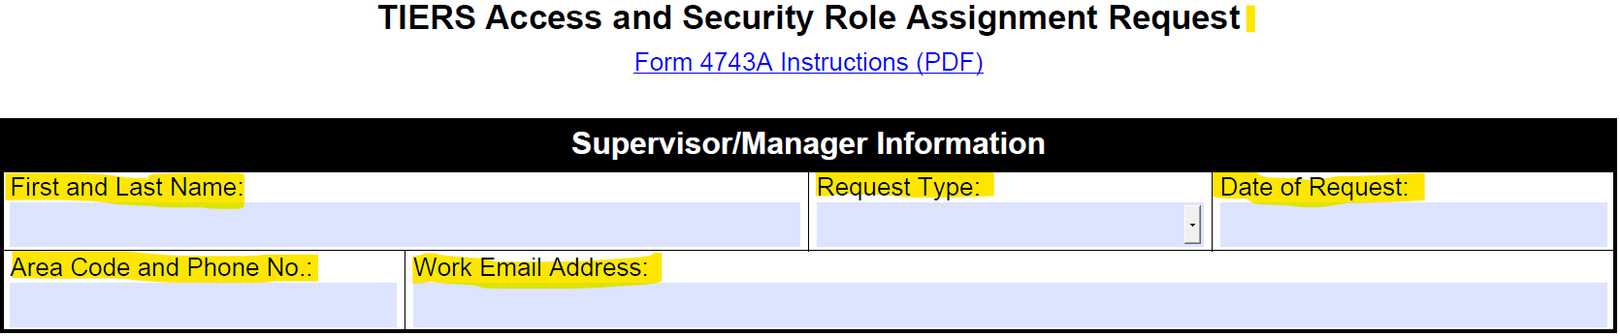

**Complete all Highlighted** items in the screen shot.

Supervisor: First and Last Name – Typed, Print – CLEARLY and NEATLY to ensure readability and minimize data entry errors.

Request Type: click on the drop-down arrow to select the access being requested:

* Add New
* Delete
* Modify (this is equivalent to REACTIVATION)

Date of Request:

Supervisor: Area Code and Phone No:

Supervisor: Work Email Address

Section 2: Employee/Contractor Information:

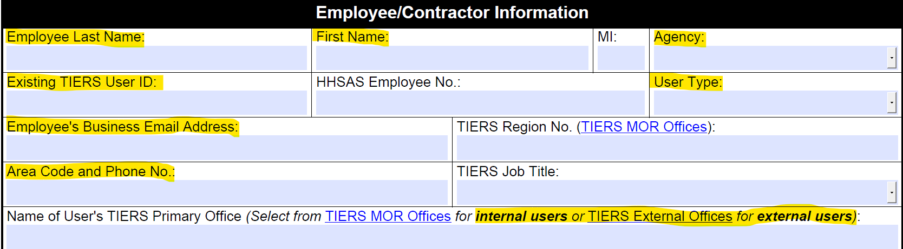

**Complete all Highlighted** items in the screen shot.

Employee: First and Last Name – Typed, Print – CLEARLY and NEATLY to ensure readability and minimize data entry errors.

* Agency click down arrow to select TWC.
* Include Existing TIERS User ID: (If known)
* User Type: click the drop-down arrow to select – External.
* Employee: Area Code and Phone No.
* Employee’s Business Email Address
* Name of User’s TIERS Primary Office – In the field enter TWC/WDA and Board Number

**Proceed to Page 3** of the TIERS Access and Security Role Assignment Request – External Users – TIERS Functional Roles – per screen shot below check the TWC box.

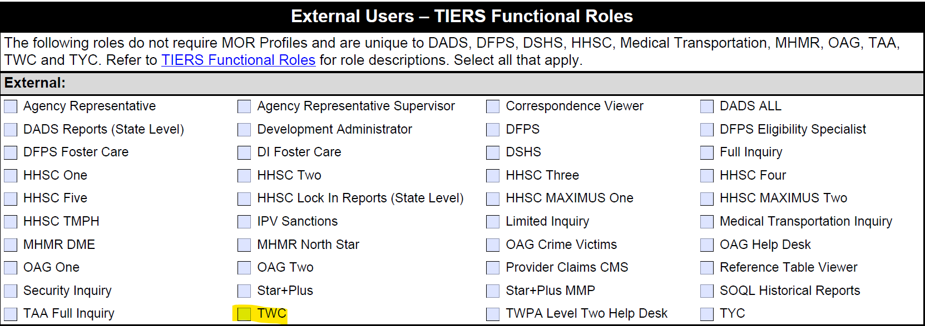

**Proceed to Page 5** of the TIERS Access and Security Role Assignment Request – Complete the Supervisor/Manager Authorization.

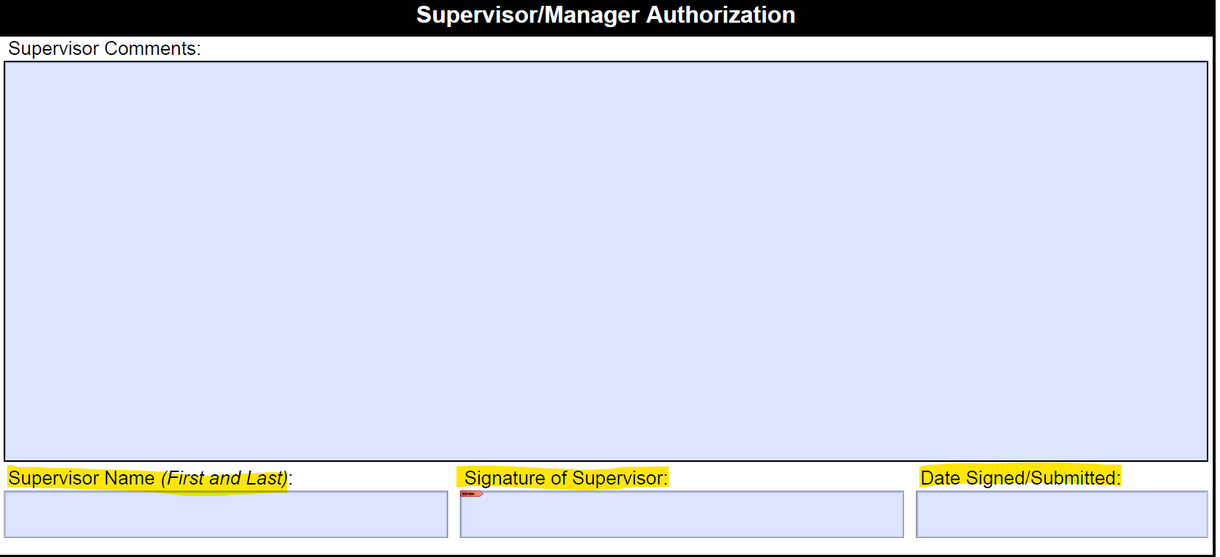

**Complete all Highlighted** items in the screen shot.

* Supervisor Name = Printed/Typed clearly
* Signature of Supervisor
* Date Signed/Submitted

**Procedure: Completing the NEW HHSC Acceptable Use Agreement**

The HHS Acceptable Use Agreement form is maintained by the Health and Human Services Commission (HHSC) and must be completed by the requestor before any access can be provided to HHSC resources (TIERS). It is an agreement between the user and the HHSC and should be read carefully before signing as it regards the sensitive information contained in the HHSC systems.

**Complete all the following Fields that are Noted as REQUIRED** as shown in the Acknowledgement screen shot below.

* AND Check the box check – An employee of another agency.

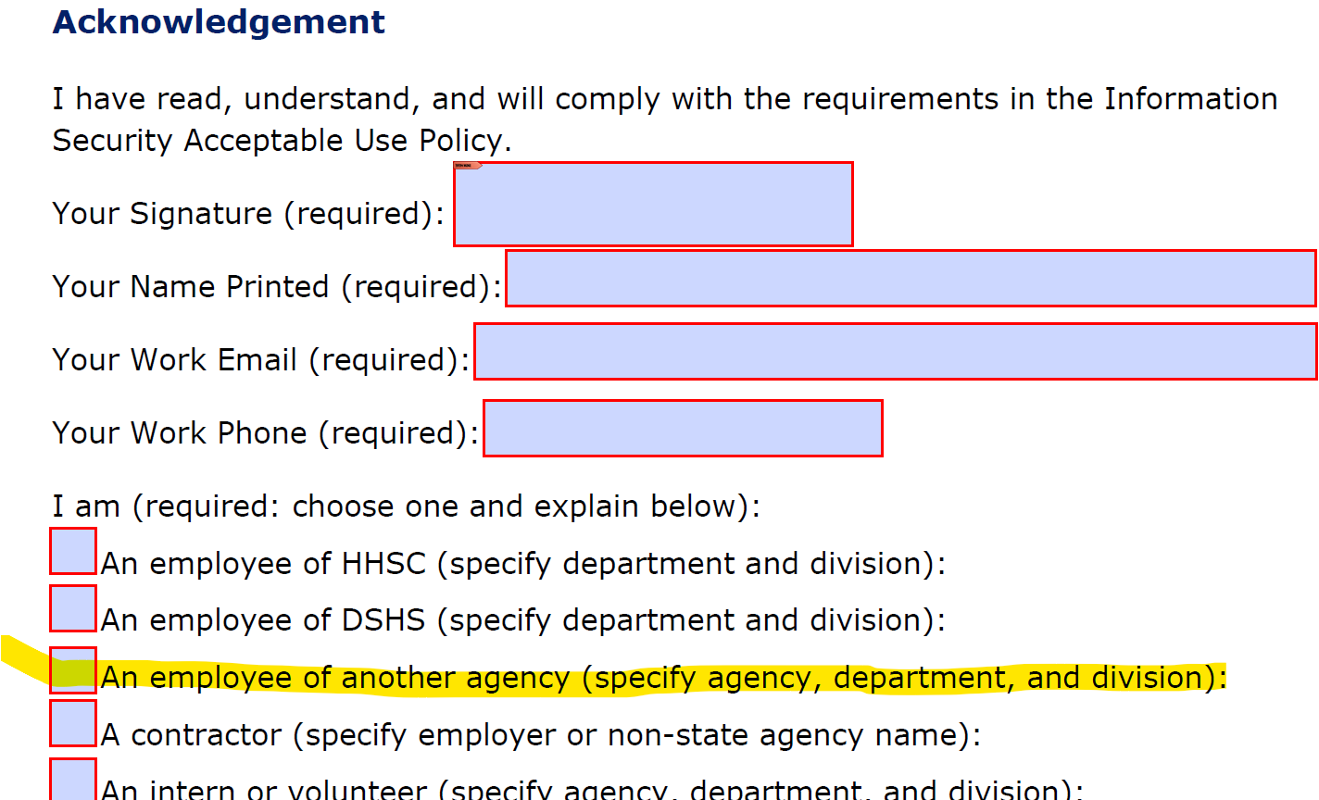

Go to the box at the bottom of the form and enter:

* + Agency - TWC or WDA (If WDA - Specify Board Number)
  + Department or Division



By signing the Texas Health and Human Services Information Security Acceptable Use Agreement form indicates that you read the **Information Security Acceptable Use Policy** provide to you in its entirety and sure that you understand it.

The submission request must include the following:

* The Form 4743A
* Signed Information Security Acceptable Use Agreement form signed by the employee accessing the TIERS system.

All TIERS request from the WDA Board must be signed by the supervisor and MUST BE SUBMITTED BY one the Combined TWIST/WIT Liaisons to the TIERS Administration for processing.